1/1/2019

Kyer Potts

30003389

Computer Games Collection

Program Report

Table of Contents

Introduction 1

Analysis 2

Test Data 3

Program Code 5

Reference Material 6

Screenshot 1 6

Screenshot 2 6

Screenshot 3 7

Screenshot 4 7

Screenshot 5 8

Screenshot 6 8

Screenshot 7 9

Screenshot 8 9

Screenshot 9 10

Screenshot 10 10

Screenshot 11 11

Screenshot 12 11

Screenshot 13 12

Screenshot 14 12

Screenshot 15 13

Screenshot 16 13

Screenshot 17 14

Screenshot 18 14

Screenshot 19 15

# Introduction

The computer games collection program was created to allow users to organise and track their computer game collection via an automatically sorted list.

The program needed to allow the user to perform the following actions:

* Add and delete entries into the list
* Search for entries in the list
* Update or change the values of a selected entry within the list
* Clear the list of all user entered data
* Save the collected data into a binary file upon closing the program
* Load pre-saved data into the program and populate the list from the saved data when the program executes
* Display tooltips for textboxes explaining their function

# Analysis

The following table will itemise the functional aspects of the program:

|  |  |
| --- | --- |
| **Input** | * User entered string data to text box fields * Click events on buttons * List Box index selection for various features * Binary file data |
| **Process** | * Add string data to array with entries controller * Delete string data from array with entries controller * Clear data from textbox controls * Reset locally saved array data with entries controller * Update selected list box entry with new data from textbox controls * Search for array data that matches data added to “Name:” textbox controller * Save current “entries” and array data to binary file * Save current “entries” and array data to binary file on click and program termination * Load saved binary file data into “entries” and array variables on click and program execution |
| **Output** | * Display sorted added entries in list box * Display error message advising all fields not entered * Remove deleted entries from list box * Show empty textbox controls on “Clear” click * Show empty list box on “Reset” click * Show updated information in list box on “Update” click * Display error message advising all fields not entered * Select list box index matched to string “Name” textbox controller input * Display error message advising search not found * Create/Overwrite binary file * Display data loaded from binary file within list box * Display message advising no save data was found |

# Test Data

|  |  |  |  |
| --- | --- | --- | --- |
| **Test Case** | **Description** | **Expected Outcome** | **Evidence** |
| Case 1. | Add game | Data is added to arrays then sorted and list box is populated with array data | Refer to Screenshot 1 |
| Case 2 | Add game (missing data) | Display Error Message | Refer to Screenshot 2 |
| Case 3 | Delete Game | Data is removed from array based upon list box selection and list box is updated with modified array data | Refer to Screenshot 3 |
| Case 4 | Delete games (no selection) | Display error message | Refer to Screenshot 4 |
| Case 5 | Clear Fields | Clears the textboxes of any data from selection or | Refer to Screenshot 5 |
| Case 6 | Reset Data | Resets array controller to ‘0”, repopulates list box with reset array controller values | Refer to Screenshot 6 |
| Case 7 | Update Entry | Updates data values of selected entry with new data added to text box fields | Refer to Screenshot 7 and 8 |
| Case 8 | Search for Entry | Searches name array for the exact match of the name field and selects appropriate index in list box | Refer to Screenshot 9 and 10 |
| Case 9 | Save on Click | Saves array data into binary file upon button click | Refer to Screenshot 11 and 12 |
| Case 10 | Load on Click | Loads Array data from previously saved dat file upon button click | Refer to Screenshot 13 and 14 |
| Case 11 | Load on Click (no save file) | Displays message advising there is no save data to load | Refer to Screenshot 15 |
| Case 12 | Load on Execute | Loads Array data from previously saved dat file upon form execution | Refer to Screenshot 16 |
| Case 13 | Load on Execute (no save file) | Displays message advising there is no save data to load | Refer to Screenshot 17 |
| Case 14 | Save on Form Close | Saves the current array data into binary file on program close | Refer to Screenshot 18 |
| Case 15 | Display Tooltip | Displays tooltips on text field mouseover | Refer to Screenshot 19 |

# Program Code

* DisplayNames()
  + Display names method to populate entries into listbox
* ClearTBs()
  + Clears the textbox controls of any data
* BubbleSort(string[]
  + Sorts entries by alhpabetical order of names array
* BinarySearch(string[], string)
  + ) Searches the listbox for matched strings based on user input in the "Name" control
* WriteFile(int, string[], string[], string[])
  + Save "entries" and array data into binary file
* ReadFile()
  + Read "entries" and array data from previously saved binary file

# Reference Material

### Screenshot 1

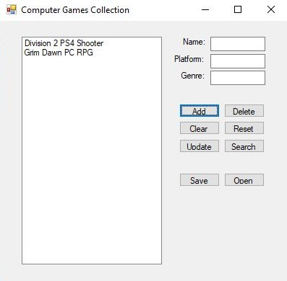

### Screenshot 2

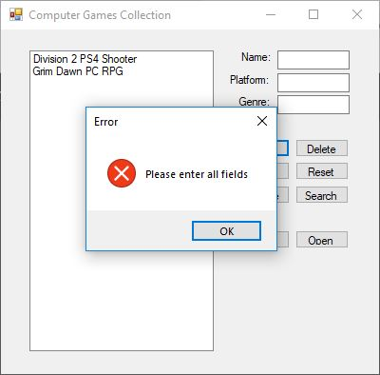

### Screenshot 3

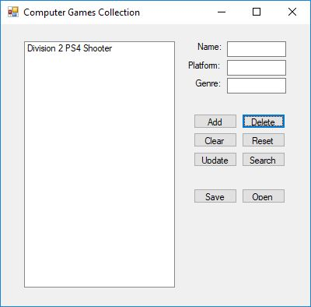

### Screenshot 4

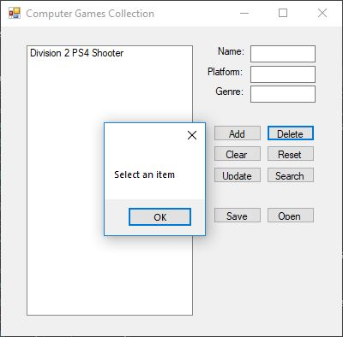

### Screenshot 5

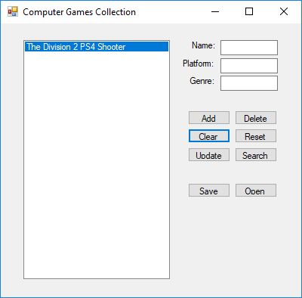

### Screenshot 6

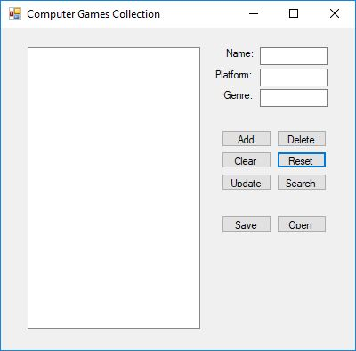

### Screenshot 7

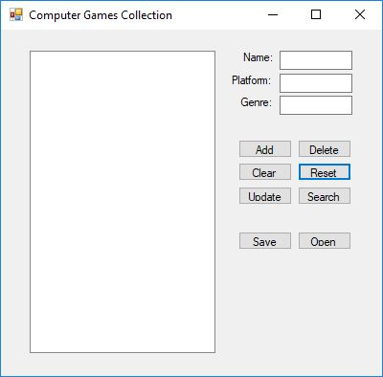

### Screenshot 8

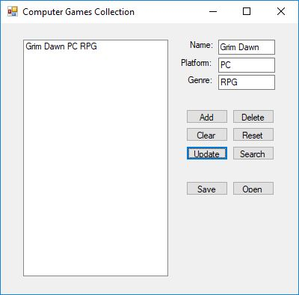

### Screenshot 9

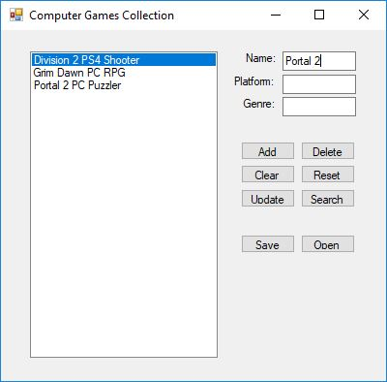

### Screenshot 10

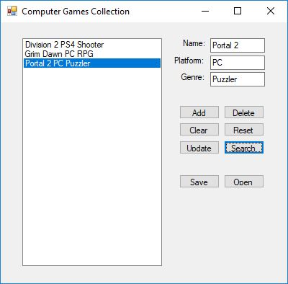

### Screenshot 11

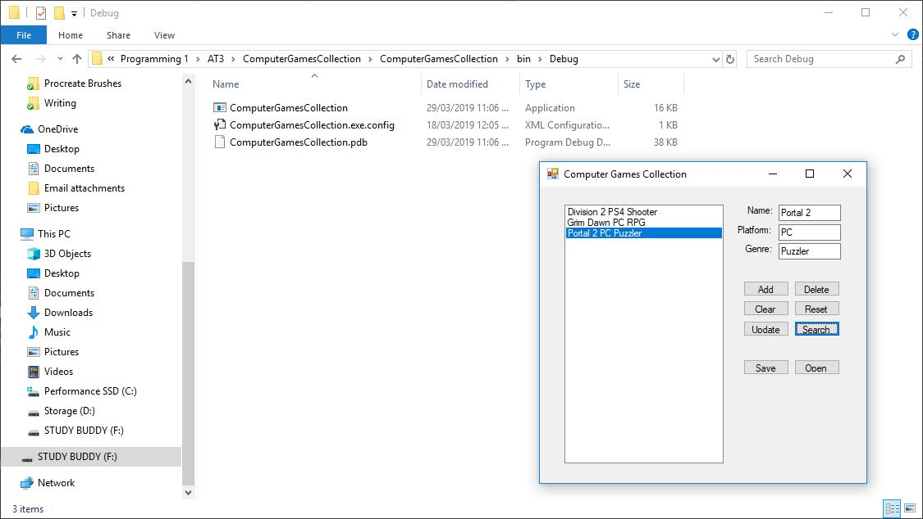

### Screenshot 12

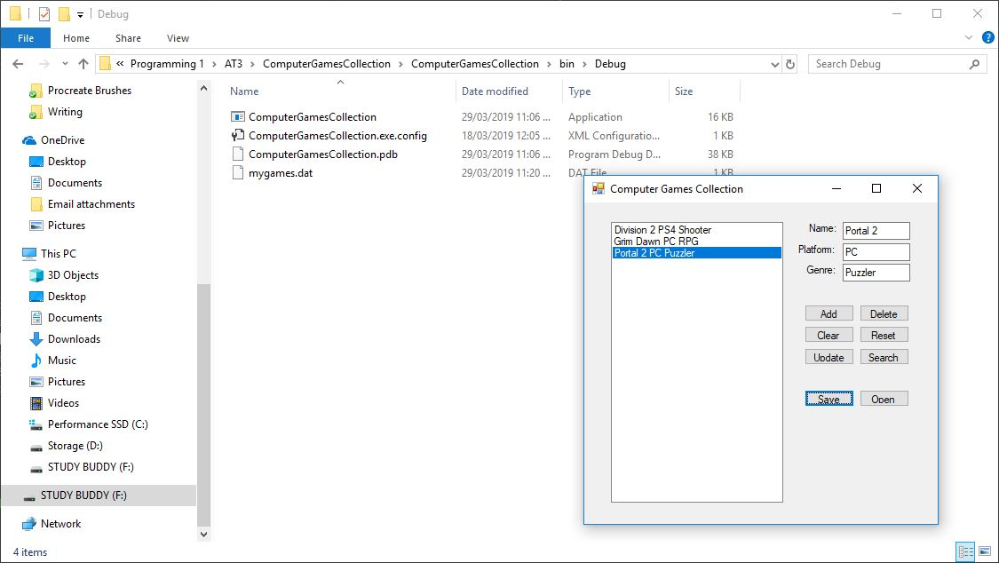

### Screenshot 13

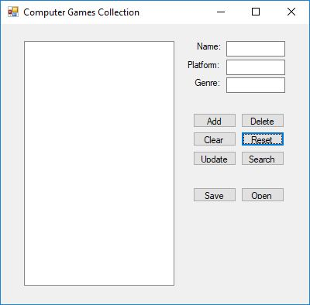

### Screenshot 14

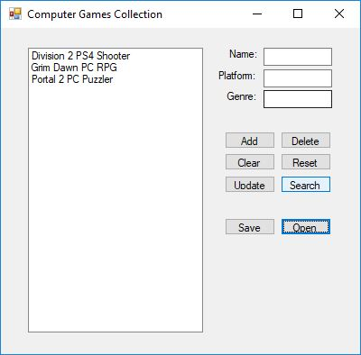

### Screenshot 15

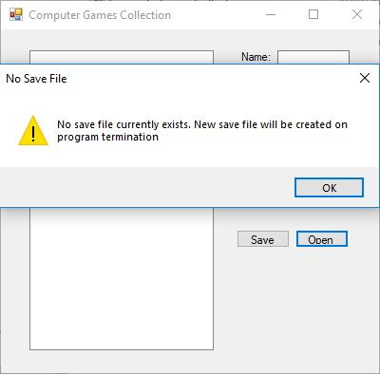

### Screenshot 16

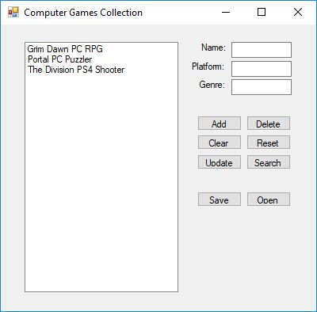

### Screenshot 17



### Screenshot 18

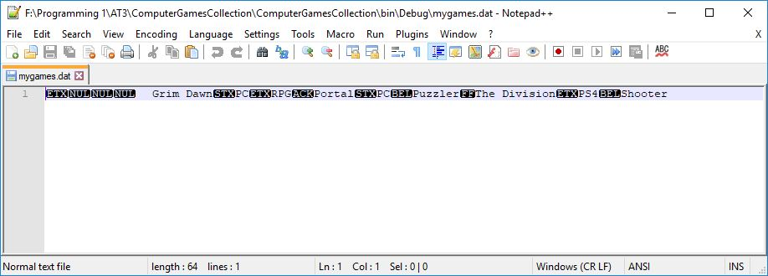

### Screenshot 19

